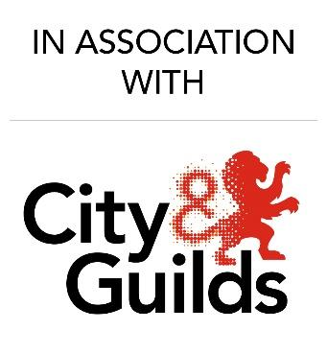

APPLICATION for the City & Guilds Barbering competition 2023-2024

Name: _______________________________________

Address: _______________________________________

_______________________________________

_______________________________________

Telephone: ____________________________

Email Address: ____________________________

This Competition is open for Apprentice / Trainee / Students only.

Look required: Editorial cut and finish.
Please follow the below steps on how to correctly enter this competition:
Step 1 – Fill out the above application form
Step 2 – Submit/Attach before and after photographs – front, back and side views
Step 3 – Add your full name into the subject line on your email
Step 4 – Send your entry to info@mhfed.com

